MongoDB Assignment A
Haadiya Hasan Faruqi

- Creating a new database called student_management and adding a collection called students inside of it ➖

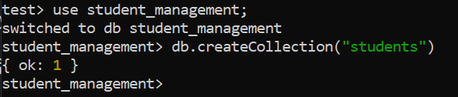

- Inserting the records into MongoDb Compass 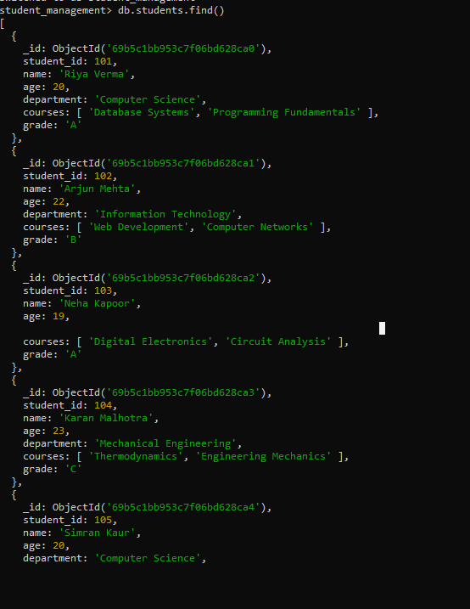

- Query the Collection:
Write queries to perform the following tasks:
- Retrieve all students who are in the "Computer Science" department.
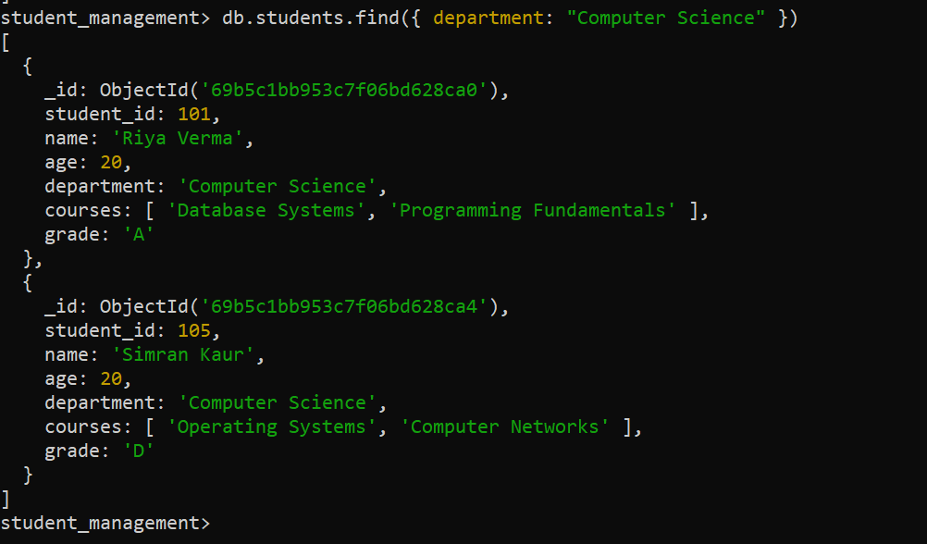

- Retrieve students who have an age greater than 21.
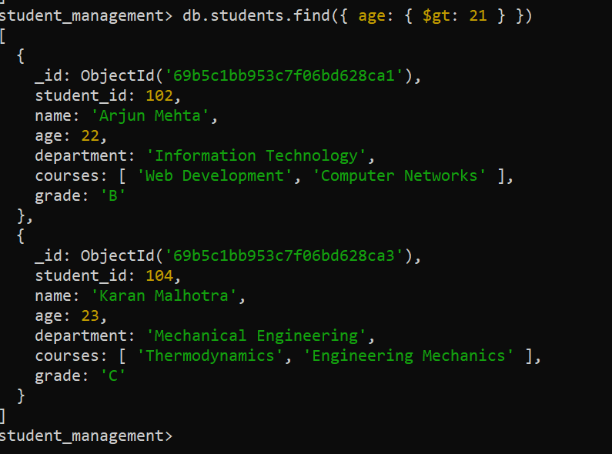

- Retrieve students who are taking the "Database Systems" course.
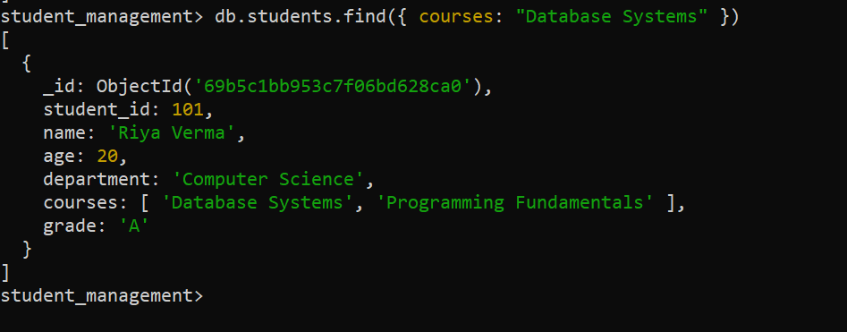

- Retrieve students with a grade of "A".
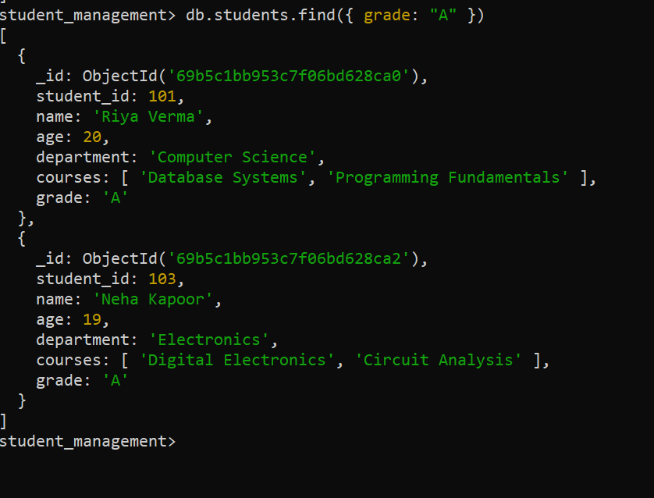

- Update Documents:
- Update the age of a student with student_id 101 to 21.
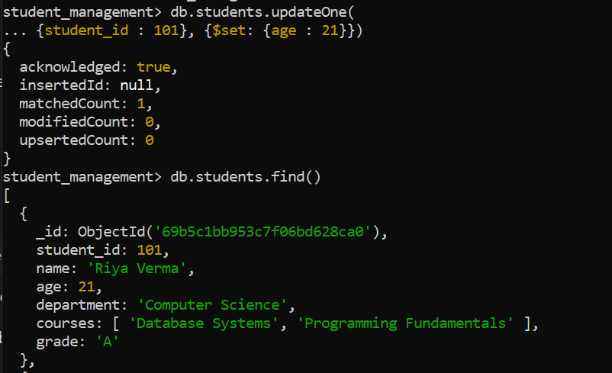

- Add a new course, "Machine Learning", to the courses array for students in the "Computer Science" department.
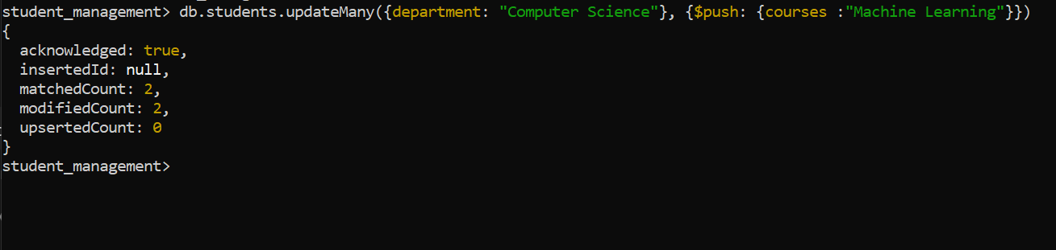
- Delete Documents:
- Delete a student record with student_id 105.

- Delete all students who have a grade lower than "C".
